PRODUCT SPECIFICATION
Maintenance of IO-Link Systems: Smart Sensors
Model IM4330

Field | Value
Product Code | IM4330
Product Range | Industrial Maintenance
Curriculum Codes | CP7395 – Industry 4.0 IO-Link | CP3723 – Maintenance on Smart Sensors
Power Supply | 24 V DC (all components; Pi via internal DC-to-DC converter)
Date | 2026-06-26
Prepared by | Matrix Technology Solutions Ltd — development@matrixtsl.com

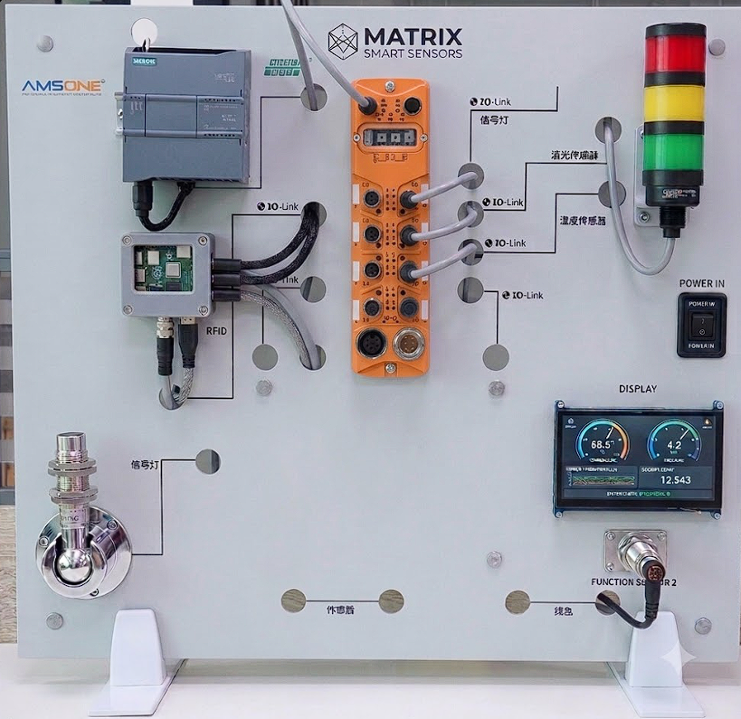
Contents
1. Educational Purpose 4
2. Learning Outcomes 5
CP3723 — Maintenance on Smart Sensors (9 modules) 5
CP7395 — Industry 4.0 IO-Link (11 modules) 5
3. How the Product Functions in Practice 6
Data Flow 6
ISDU Parameter Access 6
Fault Scenario Injection 6
Light Stack Control 6
Logging and Progress Tracking 6
4. System Architecture 7
Component Roles 7
5. Key Features 8
System Hardware & Design 8
Curriculum & Learning 8
Fault Simulation & Troubleshooting 8
6. Learning Objectives 9
7. Worksheet Index 10
CP3723 — Maintenance on Smart Sensors 10
CP7395 — Industry 4.0 IO-Link 10
8. Curriculum Front Page 11
9. Main Components 12
IO-Link Master — IFM AL1350 12
Photoelectric Sensor — Contrinex LTR-M18PA-PMS-603 12
Proximity Sensor — Omron E2E-X16MB1T12 12
Capacitive Sensor — Carlo Gavazzi / RS PRO M18 12
Temperature Sensor — IFM TV7105 (PT100) 12
Light Stack — Banner CL50 Pro RGB 13
HMI — Raspberry Pi 4 + WaveShare 1024×600 13
10. Frequently Asked Questions 14
11. Tender Specification 15
Hardware Specification 15
Control & Communication 15
Performance Expectations 15
Software & Curriculum 15
Scope of Delivery 16
12. Hardware Features 17
Panel and Mounting 17
Materials 17
IP Ratings 17
13. Control and Communication Capabilities 18
HMI Interface 18
Communication Interfaces 18
USB 18
Remote Access 18
14. Performance Expectations 19
Real-Time Data 19
Digital Control 19
System Load (Raspberry Pi 4) 19
15. Electrical Safety Information 20
Key Safety Notes 20
Maintenance and Inspection 20
Fault Handling 20
Standards Compliance 20

1. Educational Purpose
The Maintenance of IO-Link Systems: Smart Sensors (IM4330) teaches the dynamics of industrial IO-Link sensor networks in a live, hands-on training environment. Rather than simulating sensor behaviour, every interaction — reading a process value, writing a setpoint, diagnosing a fault — takes place on real industrial hardware connected over a live IO-Link bus.
The kit bridges the gap between classroom theory and workplace practice. Learners build the skills demanded by modern industrial maintenance roles: commissioning IO-Link sensors from scratch, reading and writing ISDU parameters without interrupting the live data stream, diagnosing faults through device identity checks and event flags, and using a real HMI dashboard to guide maintenance decisions.
Every fault scenario injects a real misconfiguration into the live sensor — inverted output logic, calibration drift, wrong setpoints — and the student must observe the anomaly, diagnose the root cause via ISDU reads, and write a corrective value, exactly as a field engineer would.

2. Learning Outcomes
The kit delivers two structured curriculum units totalling 19 guided hands-on modules across two progressive courses.

CP3723 — Maintenance on Smart Sensors (9 modules)
Students are introduced to each device in the kit, interact with live process data, and work through commissioning and fault-diagnosis exercises. By the end of CP3723 a learner can:
- Identify and describe all components in the IO-Link kit
- Commission sensors and verify live process data on the HMI
- Adjust setpoints and calibration offsets via ISDU
- Diagnose and correct sensor faults using IO-Link diagnostics
- Interpret the HMI dashboard to guide a maintenance decision

CP7395 — Industry 4.0 IO-Link (11 modules)
A technically deeper second tier for learners pursuing engineering-level understanding. By the end of CP7395 a learner can:
- Decode raw PDin hex payloads at the byte and bit level
- Map IO-Link data to PLC address blocks
- Quantify the maintenance cost advantage of IO-Link vs conventional wiring
- Encode and decode PDout control words for an LED light stack
- Explain the MQTT push architecture and its advantages over HTTP polling

3. How the Product Functions in Practice

Data Flow
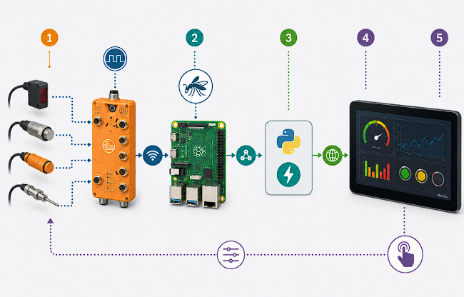
Step | Description
1 | The IFM AL1350 IO-Link Master polls its four sensor ports every 1–5 ms and buffers the latest process data.
2 | Every 500 ms the master publishes a structured payload to a Mosquitto MQTT broker running on the Raspberry Pi.
3 | The FastAPI Python backend subscribes to the MQTT broker and broadcasts data over a WebSocket to any connected browser.
4 | The Chromium kiosk (1024×600 WaveShare touchscreen) renders live gauges, charts, and status indicators — updated without page refresh.
5 | Students interact with sensors via ISDU controls on the HMI — every write reaches the sensor in under 200 ms.

ISDU Parameter Access
Students write setpoints, calibration offsets, and output logic values directly to running sensors without stopping the live data stream. A circuit-breaker in the backend protects the AL1350 from overload; adaptive polling reduces traffic to ports without a connected device.

Fault Scenario Injection
Worksheets include guided fault scenarios where a real misconfiguration is written to the live sensor via ISDU — for example, inverting proximity output logic to NC, or injecting a +3 °C calibration offset. Students observe the anomaly on the HMI, diagnose the root cause, and write a corrective value. Auto-restore logic ensures sensors return to a safe state if the exercise is abandoned.

Light Stack Control
The Banner CL50 Pro on Port 4 is controlled in real time via 3-byte PDout commands. The HMI provides a colour picker, animation selector, live hex preview, and a server-side intensity sweep effect. Worksheets include a full PDout encoding exercise.

Logging and Progress Tracking
Student progress (worksheets visited, MCQ answers) is tracked per session and can be exported as a JSON file from the Progress page at any time.

4. System Architecture
IFM AL1350 IO-Link Master ←── IO-Link (M12) ───→ Port 1: Photoelectric Sensor
│ Port 2: Proximity Sensor
│ Port 3: Capacitive Sensor
│ Port 4: Temperature Sensor
│ Port 5: CL50 Light Stack (PDout)
│
Ethernet (192.168.7.x)
│
Raspberry Pi 4
├── Mosquitto MQTT Broker ←── 500 ms push from AL1350
├── FastAPI Backend ←── WebSocket to browser
└── Chromium Kiosk ←── 1024×600 WaveShare Touchscreen

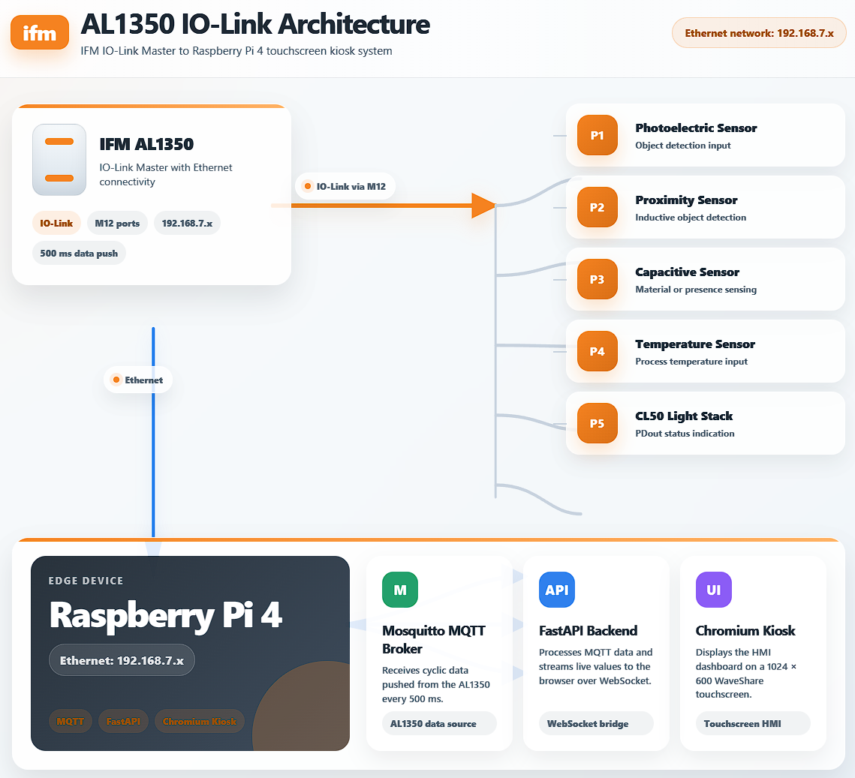

Component Roles
Component | Role
IFM AL1350 IO-Link Master | Bridge between IO-Link sensor bus and Ethernet. Handles IO-Link protocol, buffers PDin/PDout, provides REST API and MQTT publish at 500 ms. | 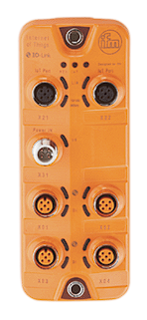
Mosquitto MQTT Broker | Lightweight pub/sub broker on the Pi. Receives 500 ms pushes from the AL1350; decouples backend from master. | 
FastAPI Backend (Python) | Subscribes to MQTT, decodes PDin payloads, manages ISDU read/write, forwards live data over WebSocket. Includes circuit-breaker and HTTP fallback. | 
Chromium HMI Kiosk | Full-screen dashboard on the WaveShare touchscreen. Live gauges, charts, IODD parameter cards. | 
Contrinex LTR-M18PA (Port 1) | Diffuse photoelectric sensor, M18, IO-Link SSC1. Configurable switch point and output logic. | 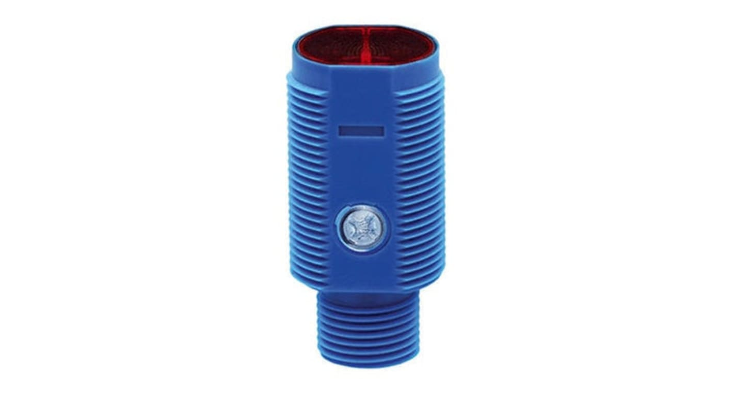
Omron E2E-X16MB1T12 (Port 2) | Inductive proximity sensor, M18, IO-Link COM2. PDin: monitor amplitude + OUT1/alarm flags. | 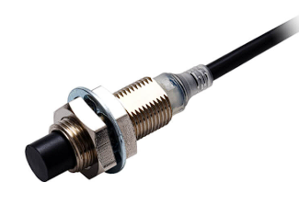
Carlo Gavazzi Capacitive sensor (Port 3) | Capacitive sensor, M18, IO-Link. SSC1 setpoint + quality-of-target via ISDU. | 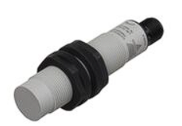
IFM TV7105 (Port 4) | PT100 temperature sensor, IO-Link. Two switching outputs with SP/RP. Calibration offset via ISDU. | 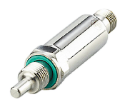
Banner CL50 Pro (Port 5) | 50 mm RGB LED light stack. PDout-only. 3-byte PDout control word: colour, animation, intensity. | 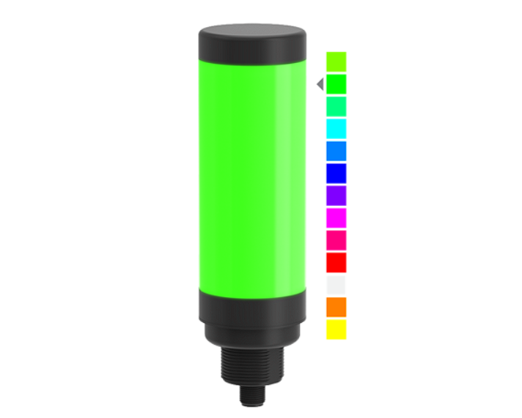

5. Key Features

System Hardware & Design
- IFM AL1350 IO-Link master (IoT Core) with four configurable IO-Link ports
- Five live IO-Link devices pre-mounted and wired on a compact training panel: Contrinex photoelectric, Omron proximity, RS PRO capacitive, IFM TV7105 temperature, Banner CL50 Pro light stack
- Raspberry Pi HMI dashboard on a WaveShare 1024×600 capacitive touchscreen
- Real-time data delivered by MQTT push at 500 ms with automatic HTTP polling fallback
- Self-contained — no PC or internet connection required for normal operation
- Modular bench-top design for classroom or training-bench use
- CE/RoHS compliant; finger-safe, low-voltage (24 V DC) wiring throughout

Curriculum & Learning
- IO-Link communication theory and Industry 4.0 smart-sensor concepts in a real industrial context
- Device commissioning, IODD parameter configuration, and ISDU read/write on live hardware
- Fault detection, diagnostics, and root-cause analysis on a live network
- Hands-on HMI dashboard, diagnostics page, and per-sensor IODD parameter cards
- Two structured curriculums — 19 guided worksheets aligned to UK T-Level and BTEC qualifications
- Built-in student-progress tracking with JSON export for assessment

Fault Simulation & Troubleshooting
- Software-injected faults written live to sensors via ISDU (proximity logic inversion, temperature calibration drift, wrong setpoints)
- Randomised fault-diagnosis scenarios from a pool covering sensor, identity, and communication faults
- Auto-restore on navigation — sensors return to a known-good state after each scenario
- Fault indication via HMI dashboard, connection-diagnostics page, and CL50 status light stack

6. Learning Objectives
By the end of this curriculum, learners will be able to:
Objective | Description
Explain the Function of IO-Link Systems | Demonstrate a clear understanding of how IO-Link point-to-point communication operates, including the role of the master, devices, IODD files, and process/service/event data.
Identify and Describe Smart Sensors and Components | Accurately identify a range of IO-Link devices and their working principles, including photoelectric, inductive, capacitive, and temperature sensors and signal-tower outputs.
Interpret System Behaviour and Diagnose Faults | Analyse live sensor data to identify abnormal conditions, isolate faults, and determine appropriate corrective actions using a structured fault-finding approach.
Configure and Maintain Smart Sensors | Read and write device parameters via ISDU, set switch points and reset points, calibrate sensors, and verify corrected behaviour against the process data.
Apply Practical Maintenance and Troubleshooting Skills | Gain hands-on experience with simulated real-world scenarios, using diagnostic tools, interpreting device feedback, and applying safe, effective maintenance practices.
Develop Confidence in Industrial Maintenance Tasks | Build competence and confidence in commissioning devices, interpreting visual indicators and status LEDs, and using the HMI dashboard to guide maintenance decision-making.

7. Worksheet Index

CP3723 — Maintenance on Smart Sensors
# | Title | Key Activities
WS1 | Meet Your Kit | Kit tour, live proximity/capacitive challenge, MCQ knowledge check
WS2 | What is a Smart Sensor? | Digital vs analogue vs IO-Link animations, randomised fault diagnosis scenario
WS3 | The Photoelectric Sensor | Optical sensing, SSC1 switch point, ISDU output-logic configuration
WS4 | The Proximity Sensor | Inductive sensing, ISDU output-logic misconfiguration scenario, guided fix and verify
WS5 | The Capacitive Sensor | Commissioning challenge, SSC1 setpoint write, detection counter via ISDU
WS6 | The Temperature Sensor | SP/RP setpoint control, calibration drift scenario (CAL-0189), ISDU offset write
WS7 | The Light Stack (Status LED) | CL50 PDout colour/animation control, maintenance scenario, live sweep demo
WS8 | Fault Finding and Replacement | NC proximity fault + light stack clue, end-to-end field diagnosis exercise
WS9 | Final Practical Assessment | Hex decode, PDout colour task, knowledge-check MCQ across all four devices

CP7395 — Industry 4.0 IO-Link
# | Title | Key Topics
WS1 | Your System — A Technical Brief | System architecture, component roles, network topology
WS2 | How This App Works | FastAPI, WebSocket, MQTT, Vite frontend, reliability patterns
WS3 | How Each Sensor Works (Protocol Level) | IO-Link PDin structure, IODD, cyclic vs acyclic data
WS4 | Benefits for Maintenance | Remote reconfiguration, predictive diagnostics, cost comparison
WS5 | Decoding IO-Link Data | PDin hex decode exercises, dtype table, scale factors, two's complement
WS6 | Diagnostics: Process, Service, and Event Data | Event flags, ISDU service channel, supervision data
WS7 | PLC and HMI Integration | IO-Link Master as gateway, PROFINET/EtherNet-IP mapping concepts
WS8 | Case Study — Standard vs IO-Link: The Numbers | Wiring cost, commissioning time, fault MTTR, 5-year TCO
WS9 | Device Identity — Vendor ID, Device ID & PDin | Vendor/device ID registry, live identity reads, IODD lookup
WS10 | PT100 Temperature Sensors | IEC 60751 accuracy, resistance curve, PDin hex decode, calibration offset
WS11 | CL50 Pro — PDout Encoding Deep-Dive | 3-byte PDout structure, bit-field encoding, colour index table, hex preview

8. Curriculum Front Page
IO-Link Smart Sensor Training Kit
Model IM4330 · CP3723 & CP7395

Courses | CP3723 — Maintenance on Smart Sensors | CP7395 — Industry 4.0 IO-Link
Level | Introductory (CP3723) / Engineering (CP7395)
Format | Self-paced, live hardware, browser-based HMI
Audience | FE students and apprentices aged 16–18; T-Level / BTEC engineering
Prerequisites | Basic electrical knowledge. No IO-Link or programming experience required.

This training kit puts you in front of a real, running IO-Link sensor network. You will not watch a simulation — you will read live data from real sensors, write parameters that change how they behave, and fix faults you have injected yourself.

Hardware | Software
IFM AL1350 IO-Link Master | Raspberry Pi HMI Dashboard
Contrinex Photoelectric Sensor | FastAPI Backend + MQTT Push
Omron Proximity Sensor | Browser-based Worksheets
RS PRO Capacitive Sensor | Live ISDU Read/Write Controls
IFM TV7105 Temperature Sensor | Progress Tracking + JSON Export
Banner CL50 Pro LED Light Stack

9. Main Components
All components are pre-mounted and wired on the training panel at delivery.

IO-Link Master — IFM AL1350
Purpose: Central IO-Link master connecting all field devices to the network and HMI dashboard.
- Four configurable IO-Link / digital-I/O ports
- IoT Core REST + MQTT interface for live data push at 500 ms
- Acyclic ISDU read/write for full device parameter access
- On-board supervision: port voltage, current, and temperature
- IP67 rated; 24 V DC supply

Photoelectric Sensor — Contrinex LTR-M18PA-PMS-603
Purpose: Detects objects optically; demonstrates light-based sensing over IO-Link.
- M18 housing, IO-Link switch signal channel (SSC1)
- Configurable switch point and output logic via ISDU
- Teach-in, cancel, and factory-reset commands
- IP67 rated; M12 5-pin quick-connect cable

Proximity Sensor — Omron E2E-X16MB1T12
Purpose: Detects metal objects inductively; demonstrates discrete sensing and diagnostic flags.
- OUT1 object-detected flag plus instability and over-approach alarms
- Monitor-output amplitude value in process data (16-bit PDin)
- Switchpoint logic (NO/NC) configurable via ISDU
- 16 mm sensing range; IP67; COM2 IO-Link

Capacitive Sensor — Carlo Gavazzi / RS PRO M18
Purpose: Detects materials through non-metallic barriers; detects liquids, powders, and solids.
- M18 capacitive switch with IO-Link SSC1 channel
- Switch point, quality-of-teach and quality-of-run parameters
- Teach start / stop / cancel commands via ISDU
- IP67 rated; M12 quick-connect

Temperature Sensor — IFM TV7105 (PT100)
Purpose: Measures process temperature; demonstrates analogue-to-IO-Link conversion.
- PT100 RTD element with IO-Link transmitter
- Two independent switching outputs, each with SP and RP (hysteresis)
- Calibration offset adjustable via ISDU (±10 °C, scale 0.1 °C/LSB)
- IP67; resolution 0.1 °C

Light Stack — Banner CL50 Pro RGB
Purpose: Multi-colour signal tower for visual system-state indication; IO-Link PDout output device.
- PDout-only IO-Link device — fully controlled from the HMI dashboard
- 16-colour palette, intensity control, animation modes (steady, flash, strobe, SOS)
- Software intensity-sweep (breathing) effect for status display
- IP65 rated; 50 mm diameter column

HMI — Raspberry Pi 4 + WaveShare 1024×600
Purpose: Runs the touch HMI dashboard and hosts all data and MQTT services locally.
- 1024×600 capacitive touchscreen in kiosk mode (Chromium on Openbox/X11)
- Real-time gauges, charts, and per-sensor IODD parameter cards
- Connection diagnostics, latency graphs, circuit-breaker state, and log viewer
- Built-in interactive worksheets and student progress tracking

10. Frequently Asked Questions
Question | Answer
What software is needed to run the system? | None. The system runs entirely self-contained — the included Raspberry Pi hosts the HMI dashboard and data services and boots straight into the touchscreen interface. Optionally, the dashboard can be opened in any modern web browser on the same network.
Does the kit come with curriculum materials? | Yes. A full curriculum is included, complete with guided student worksheets and detailed teacher notes, available through the Matrix Learning Centre.
What age group is this kit aimed at? | It's designed for further and higher education students aged 16–20 studying engineering, automation, or maintenance.
How many students can use the kit at once? | Ideal for 1 or 2 students working collaboratively. Two learners can comfortably work side-by-side during practical sessions.
How is the system powered? | Everything runs from a single 24 V DC supply. The Raspberry Pi receives 5 V via an internal DC-to-DC converter on the panel — there is no separate Pi supply. One adapter is included with UK, EU, and US plug heads. No mains wiring is required.
Do the sensors need any special media or targets? | No. The sensors detect ordinary objects placed in front of them — metal for the proximity sensor, general materials for the photoelectric and capacitive sensors — and ambient/applied temperature for the temperature sensor. No fluids or consumables are required.
Is post-use maintenance required? | Very little. Occasionally wipe the sensor faces and check cable connections.
Can I change the sensor parameters? | Yes. Every device parameter is readable and writable live from the dashboard via IO-Link ISDU, including switch points, output logic, and calibration. The worksheets guide students through safe parameter changes, and scenarios auto-restore the sensors afterwards.
Does the system simulate faults? | Yes. It includes software-injected faults written live to the sensors (e.g. inverted output logic, calibration drift, ISDU misconfiguration) and randomised fault-diagnosis scenarios to simulate real-world troubleshooting.
How is the system stored? | The entire kit, including the touchscreen, cables, and accessories, can be stored safely on a shelf or under a workbench. For long-term storage or transport, the kit can be placed back into its original shipping box.
Is the system portable? | Yes. The system is manageable by one person and designed for easy transport between classrooms or benches.
Do I need a PC to operate it? | No PC is needed for normal operation. The Raspberry Pi and touchscreen provide all necessary monitoring, configuration, and diagnostics.
Is technical training required to use the kit? | No prior experience is needed. The worksheets walk students through IO-Link operation, sensor configuration, faults, and diagnostics step-by-step.
What warranty and support is included? | The product includes a standard 12-month warranty with full technical support from Matrix TSL.

11. Tender Specification
Matrix Technology Solutions Ltd shall supply the Maintenance of IO-Link Systems: Smart Sensors training system (Model IM4330) with the following features, capabilities, and performance assurances:

Hardware Specification
- The system shall be constructed as a compact bench-top training panel with all devices pre-mounted and wired, suitable for desk-based educational environments.
- The system shall include an IFM AL1350 IO-Link master (IoT Core) providing four configurable IO-Link / digital-I/O ports with acyclic ISDU read/write.
- The system shall feature finger-safe, low-voltage (24 V DC) wiring and push-in connectors to allow easy maintenance and compact storage.
- The system shall include the following IO-Link device set: Contrinex LTR-M18PA-PMS-603 photoelectric sensor; Omron E2E-X16MB1T12 inductive proximity sensor; Carlo Gavazzi / RS PRO M18 capacitive sensor; IFM TV7105 PT100 temperature sensor with dual switching outputs; Banner CL50 Pro RGB light stack.
- The system shall include a Raspberry Pi with a 1024×600 capacitive touchscreen running the HMI dashboard in kiosk mode.

Control & Communication
- The system shall communicate with field devices over IO-Link (IEC 61131-9) via the AL1350 master.
- The system shall deliver real-time data by MQTT push at 500 ms, with HTTP polling as an automatic fallback.
- The system shall provide a web-based HMI dashboard with live gauges, charts, per-sensor IODD parameter cards, and connection diagnostics.
- The system shall support Ethernet between the IO-Link master, MQTT broker, and Raspberry Pi, and Wi-Fi / LAN for browser access from other network devices.
- The system shall operate from a single 24 V DC supply, provided with global plug adapters for UK, EU, and US regions. The Raspberry Pi is powered at 5 V via an internal DC-to-DC converter on the panel board from the 24 V rail.

Performance Expectations
- The system shall display real-time sensor values and device parameters on the HMI dashboard and allow live ISDU read/write of all registered parameters.
- The system shall support software-injected faults written live to the sensors and randomised fault-diagnosis scenarios.
- The system shall auto-restore sensors to a known-good state when a scenario is exited.
- The system shall issue visual fault indicators via the HMI dashboard, connection-diagnostics page, and status light stack.

Software & Curriculum
- The system shall be delivered with the HMI dashboard software preloaded on the Raspberry Pi for immediate training use.
- The system shall be accompanied by two curriculums and 19+ guided worksheets, aligned with UK T-Level and BTEC qualifications.
- The system shall include detailed teacher notes with expected learner outcomes and troubleshooting hints.
- The system shall provide ongoing access to digital curriculum updates and technical support via the Matrix Learning Centre.

Scope of Delivery
- IFM AL1350 IO-Link master and all five IO-Link devices preinstalled and wired on the training panel
- Raspberry Pi and touchscreen preloaded with the HMI dashboard
- Patch cables, M12 IO-Link cables, and accessories
- Global 24 V DC power supply (with internal DC-to-DC for Pi) with UK, EU, US plug adapters
- Each kit suitable for use by 1–2 students simultaneously
- Factory tested and ready to operate out of the box

12. Hardware Features

Panel and Mounting
- Bench-top training panel — all components pre-mounted and wired; no assembly required.
- Panel dimensions: TBC (target footprint ≤ 500 × 400 mm).
- M18 sensors on threaded bosses with locking nuts; quick-change via M12 5-pin quick-disconnect IO-Link cables — no tools required for sensor swap.
- IFM AL1350 mounted on a DIN-rail section within the panel.
- Banner CL50 Pro column light mounted upright for clear bench-wide visual indication.
- Raspberry Pi and WaveShare display on a tilt-adjustable stand.
- All cables spiral-wrapped and labelled.

Materials
Component | Material
M18 sensor bodies | Nickel-plated brass
Sensor faces | PBT (polybutylene terephthalate), chemical-resistant
IO-Link Master housing | Glass-fibre reinforced PA (IFM AL1350 standard)
M12 cable jacket | PUR (polyurethane), oil-resistant, rated to 70 °C
Panel baseplate | Powder-coated mild steel or ABS, RAL 7035 light grey
Display bezel | ABS plastic

IP Ratings
Component | IP Rating
IFM AL1350 | IP67
Omron E2E Sensor | IP67
RS PRO Capacitive | IP67
IFM TV7105 | IP67
Banner CL50 Pro | IP65
Raspberry Pi (in stand) | IP0 — housed in stand
WaveShare Display (front face) | IP54

13. Control and Communication Capabilities

HMI Interface
- Browser-based dashboard — runs in Chromium kiosk on the Pi, or in any modern desktop browser on the local network.
- Responsive layout: full sidebar at large screen widths; drawer sidebar in kiosk (1024×600) mode.
- Global display zoom (50–150%) with kiosk white-space compensation; persists across sessions via localStorage.
- Multiple themes (light / dark / industrial) via DaisyUI theme selector.
- Touch-capable: large hit targets, drag-to-scroll sidebar for 1024×600 touchscreen.
- Per-sensor IODD parameter cards — read and write setpoints, output logic, and calibration from the HMI.
- Connection diagnostics page: IO-Link latency graph, circuit-breaker state, MQTT status, log viewer.

Communication Interfaces
Interface | Specification | Purpose
IO-Link | IEC 61131-9, COM2/COM3 | Sensor bus — M12 3-wire, max 20 m
Ethernet | 10/100 Base-T | AL1350 ↔ switch ↔ Raspberry Pi
MQTT | MQTT 3.1.1 (Mosquitto) | 500 ms sensor data push from AL1350
WebSocket | ws:// on port 80 (nginx) | Live HMI push to browser
REST API | HTTP at /api/ (port 80) | ISDU read/write, config, diagnostics
Wi-Fi | 802.11ac (Pi 4 built-in) | Dashboard from any device on the network
LAN | mDNS: iolink.local | Browser and SSH access over Ethernet

USB
- Raspberry Pi USB-A ports for keyboard/mouse during setup.
- Progress JSON export saved to USB drive via standard browser download.

Remote Access
- SSH: standard OpenSSH server on Pi at hamed@iolink.local
- Remote Chromium debug: port 9222 always open in kiosk mode
- Web dashboard: http://iolink.local on the local network

14. Performance Expectations

Real-Time Data
Metric | Specification
HMI update latency | ≤ 500 ms sensor-to-screen (MQTT push path)
ISDU read round-trip | < 200 ms typical (browser → FastAPI → AL1350 → sensor → response)
ISDU write round-trip | < 200 ms typical
HTTP fallback polling rate | 1 Hz per connected port; 0.2 Hz per disconnected port
Circuit-breaker recovery | 15 s after 5 consecutive failures
WebSocket reconnect | Automatic; exponential back-off with jitter
Chart buffer size | 50 data points per series (Pi memory optimised)
Chart redraw rate | Once per 2 seconds (flush-throttled)
Device tree cache TTL | 5 minutes
Concurrent browser sessions | Unlimited (WebSocket broadcast)

Digital Control
- PDout writes to the CL50 light stack acknowledged within < 200 ms of HMI button press.
- ISDU parameter writes take effect at the next IO-Link cycle — typically < 5 ms after the AL1350 receives the command.
- Software intensity sweep cycles brightness at 40 / 100 / 250 ms step intervals (speed-selectable).

System Load (Raspberry Pi 4)
- Chromium renderer CPU: ~97% under normal kiosk operation.
- Python backend CPU: ~5% (adaptive polling + MQTT subscription).
- Chart.js updates throttled; mimic components skip re-render when values unchanged.

15. Electrical Safety Information
The Maintenance of IO-Link Systems: Smart Sensors training system (Model IM4330) is designed with safety in mind and complies with relevant low-voltage and EMC standards. Users must adhere to the following safety guidance to ensure safe and correct operation.

Key Safety Notes
Low Voltage Operation: The system operates from a single 24 V DC supply. The Raspberry Pi receives 5 V DC via an internal DC-to-DC converter on the panel — there is no separate Pi power supply. The system does NOT require or tolerate direct connection to mains voltage. Doing so will result in damage and void the warranty.
Power Supply: Use only the supplied power adapter with approved plug heads (UK, EU, US). It is a CE-marked unit with overvoltage and short-circuit protection.
Enclosure and Wiring: All devices are mounted on a panel with finger-safe terminals and connectors. No exposed live connections are present under normal use.
Circuit Protection: The 24 V supply is internally protected against overload and short-circuit. Do not bypass any protective device.

Maintenance and Inspection
- Only qualified personnel should service or inspect internal wiring.
- Regularly inspect external cables and sensor connectors for damage or wear.
- Do NOT modify wiring without referring to the system schematic and isolating power first.
- Always isolate power before disconnecting or reconnecting any device.

Fault Handling
Simulated Faults: All training faults are software-injected via IO-Link ISDU. They are for educational purposes only and do not affect electrical safety.
Power Isolation: To fully isolate the system, switch off or unplug the 24 V DC supply. This cuts power to all components simultaneously.
Fault Indication: The status light stack and HMI dashboard indicate fault or alarm states. Resolve any reported issue before continuing a training exercise.

Standards Compliance
Standard | Scope
IEC 61131-9 | IO-Link single-drop digital communication standard
EN 61010-1 | Safety for electrical equipment for measurement, control, and laboratory use
LVD 2014/35/EU | Low Voltage Directive — applicable to included power supplies and components
RoHS 2011/65/EU | Restriction of hazardous substances in electronic components

Note: This product is intended for educational use only and does not fall under the full scope of the Machinery Directive 2006/42/EC. It contains no actuators, moving parts, or safety-rated control functions and must not be relied upon for industrial safety purposes.

